

Game Top Up

Written to fulfill the 1st task of

**Web Programming**

Group : 4

Names : Ahmad Zainul Mufid

Bagus Adhi Nugroho

Dennis Salomo Angelos Charisteas

Class : 2 SE 2

CEP CCIT

FAKULTAS TEKNIK UNIVERSITAS INDONESIA

2023

**PROJECT ON**

*Game Top Up*

**Developed by**

1. **Ahmad Zainul Mufid**
2. **Bagus Adhi Nugroho**
3. **Dennis Salomo Angelos**



**Game Top Up**

Batch Code : 2SE2

Start Date : Tuesday, May 30, 2023  
End Date : Thursday, June 15, 2023

Name of Faculty : Muhammad Azka Ramadhan

Names of Developer :

1. Ahmad Zainul Mufid
2. Bagus Adhi Nugroho
3. Dennis Salomo Angelos Charisteas

Date of Submission: Friday, June 16, 2022



**CERTIFICATE**

This is to certify that this report titled “Game Top Up” embodies the original work done by Ahmad Zainul Mufid, Bagus Adhi Nugroho, Dennis Salomo Angelos Charisteas. Project in partial fulfillment of their course requirement at NIIT.

Coordinator:

Muhammad Azka Ramadhan

First of all, we would like to thank God because of His blessings and guidance, writers can compose and present a paper that contains about Implementation of Information Technology in an apartment, as one of IT Introductory lecture. The writer also thanked to Mr. Muhammad Azka Ramadhan as lecturer Introductory IT course that have provided guidance to the writer in the process of preparing this paper. Not to forget the writer thank the various parties who have given encouragement and motivation

The author realizes that the preparation of this project there are still many shortcomings and far from being perfect. Therefore, the authors expect constructive criticism and suggestion to improve this paper and can be reference in preparing the papers or subsequent tasks.

The authors also apologize if in writing this paper there are typos and errors that confuse the reader in understanding the author’s intent.

Depok, June , 2022

**ACKNOWLEDGEMENT**

**System Summary**:

The process of purchasing or adding credits or currency within a game using real money. It can be used to acquire subscriptions or special packages in the game, such as monthly subscriptions or rare items that cannot be obtained otherwise.

On this project, we use HTML and CSS for designing our website. Basically we made our Game Top Up web with Visual Studio Code and implement the whole components that written in Student Guide

**SYSTEM ANALYSIS**

**System Process**:

Home Page: This page contains about list game, slider animation, and footer. We also added Json time which can be changed when it comes to afternoon and evening.

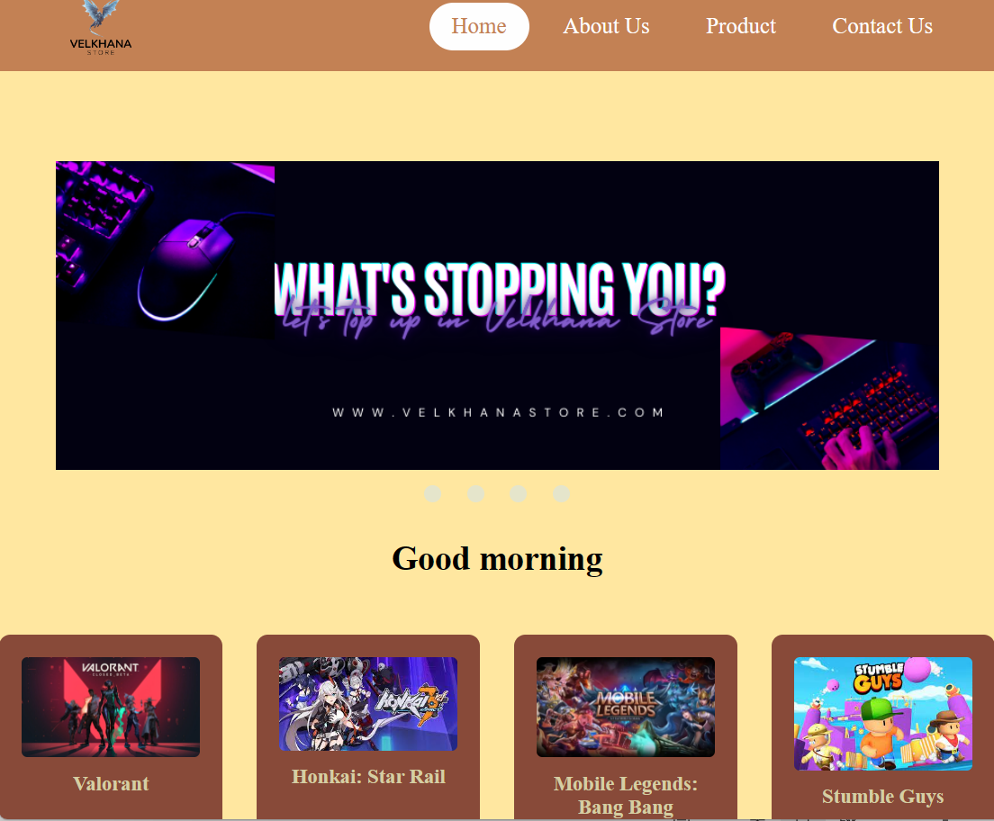

**DESIGN INTERFACE**

**(Home Page)**

**System Process**:

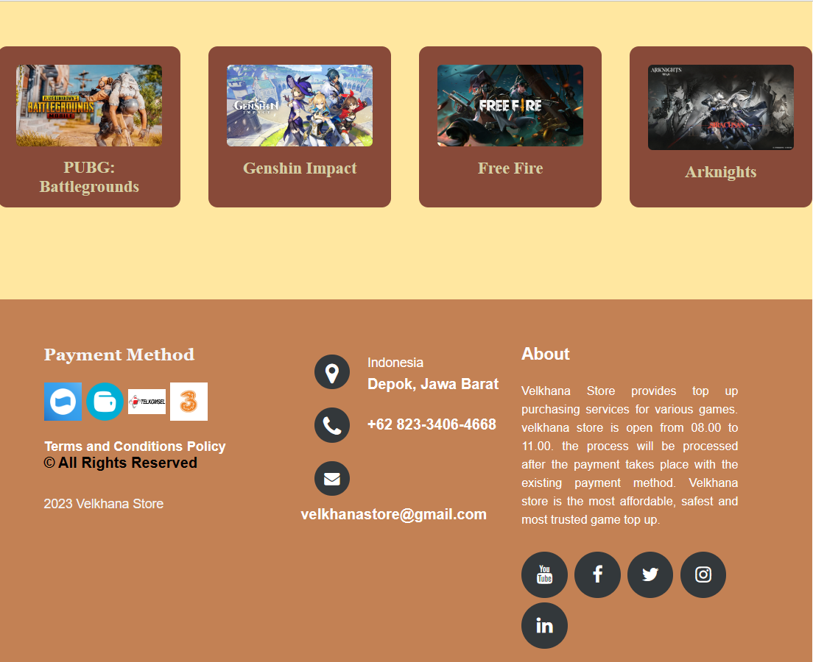

In this page there is footer about our payment method, our contact and social media, also brief info about operation time and method we have in Velkhana Store

**DESIGN INTERFACE**

**(Home Page)**

ml

**System Process**:

This page contains the developer behind Velkhana Store and brief introduction about what is Velkhana Store and what kind of service we offer

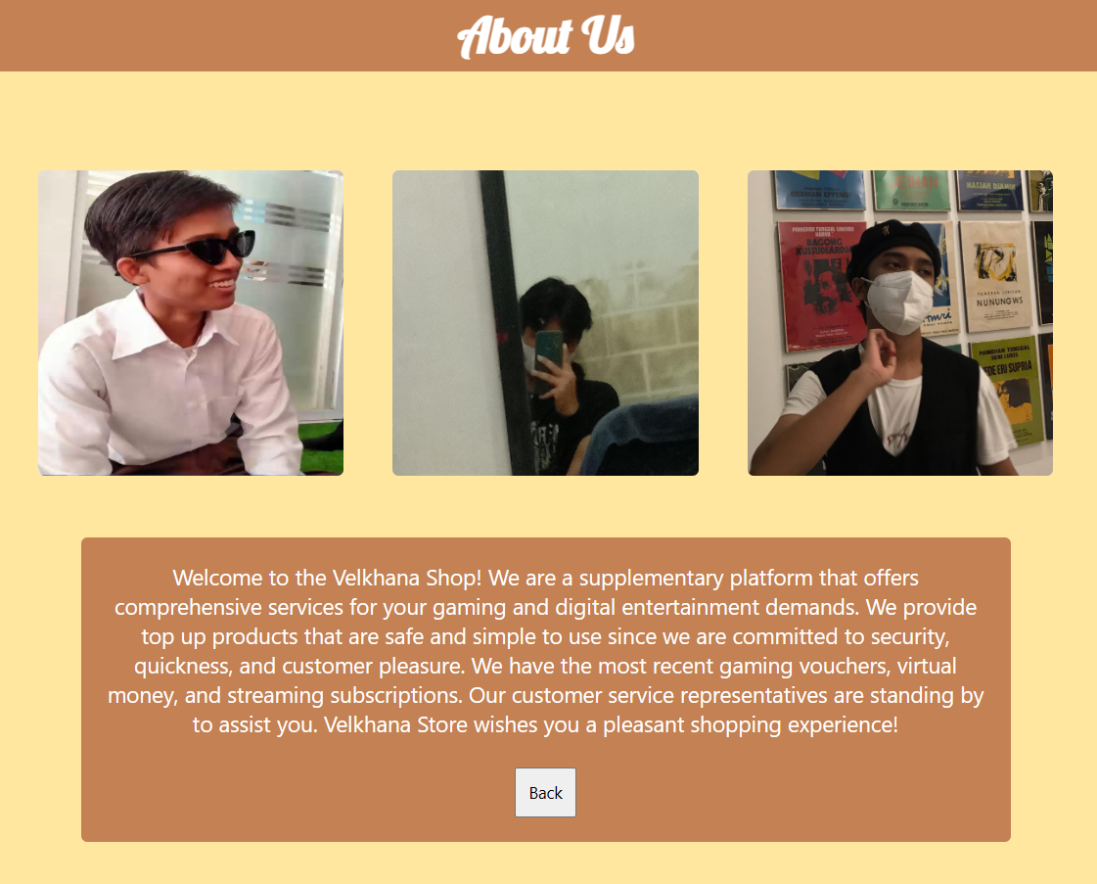

**DESIGN INTERFACE**

**(About Us Page)**

**DESIGN INTERFACE**

**(Product Page)**

**System Process**:

In Product page we display the most famous game in this year. Oncw we click the image, it will lead you to Purchase form and in this case we use Mobile Legends Bang Bang aka MLBB as an example.

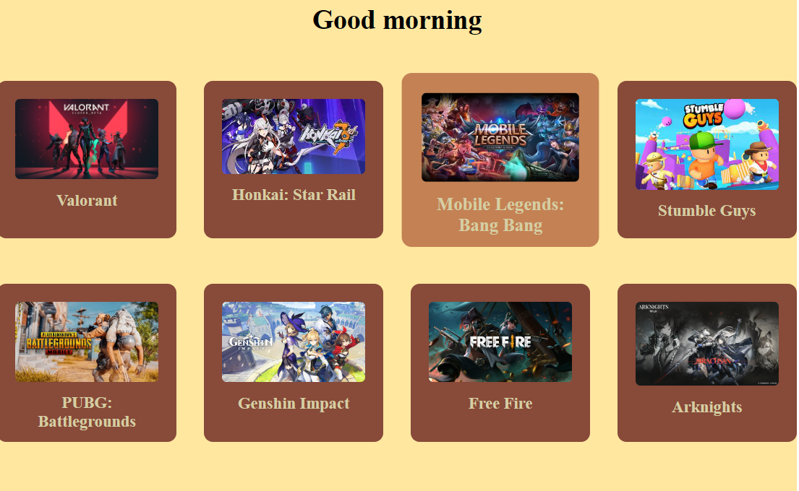

**System Process**:

This page contains about what should customer fill or do. They will input their info on the input type. We use validation to validate the data that has been inserted into the input type column.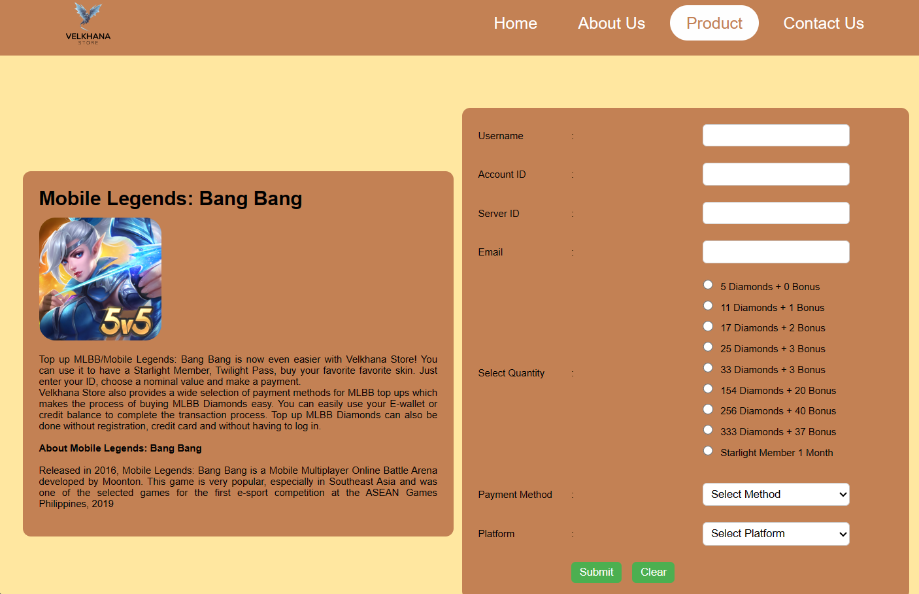

**System Process**:

**System Process**:

**System Process**:

**Hardware :** Lenovo

**Operating System :** Windows 11 Home

**Software :** Microsoft Office Word, Microsoft Office Power Point,

Visual Studio Code

|  |  |  |
| --- | --- | --- |
| **PROJECT FILE DETAILS** | | |
| **S.No** | **File Name** | **Remarks** |
| 1 | Game Top Up.docx | Paper |
| 2 | Game Top Up.pptx | Slidehow |
| 3 | Game Top Up.rar | Code |

**CONFIGURATION**